Didactic Diction

📘 What is Didactic Diction
# Source: Chatgpt (GPT-4-turbo) at [7/30/2025]
Didactic diction is language that is intended to instruct, teach, or convey a moral, ethical, or educational lesson. It is commonly used in texts where the primary goal is to educate or guide the audience rather than simply entertain.

✅ Key Features:
# Source: Chatgpt (GPT-4-turbo) at [7/30/2025]
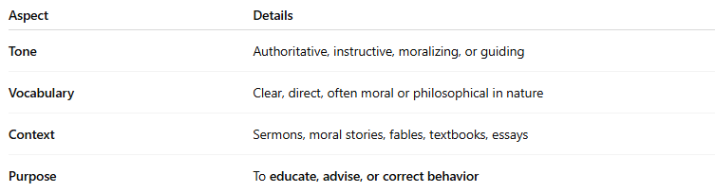
Aspect | Details
Tone | Authoritative, instructive, moralizing, or guiding
Vocabulary | Clear, direct, often moral or philosophical in nature
Context | Sermons, moral stories, fables, textbooks, essays
Purpose | To educate, advise, or correct behavior

🧠 Examples of Didactic Diction:
# Source: Chatgpt (GPT-4-turbo) at [7/30/2025]
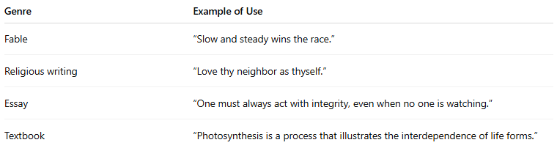
Genre | Example of Use
Fable | “Slow and steady wins the race.”
Religious writing | “Love thy neighbor as thyself.”
Essay | “One must always act with integrity, even when no one is watching.”
Textbook | “Photosynthesis is a process that illustrates the interdependence of life forms.”

✍️ Example Sentences Using Didactic Diction:
# Source: Chatgpt (GPT-4-turbo) at [7/30/2025]
- “Children must learn the value of honesty, for it is the foundation of trust.”
- “The pursuit of knowledge should not come at the expense of humility.”

🆚 Didactic Diction vs Formal Diction:
# Source: Chatgpt (GPT-4-turbo) at [7/30/2025]
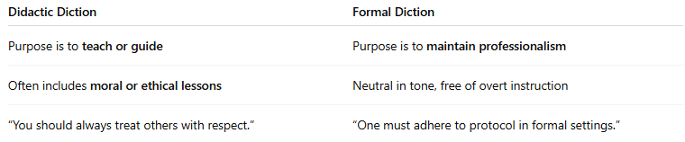
Didactic Diction | Formal Diction
Purpose is to teach or guide | Purpose is to maintain professionalism
Often includes moral or ethical lessons | Neutral in tone, free of overt instruction
“You should always treat others with respect.” | “One must adhere to protocol in formal settings.”

🧭 Used In:
# Source: Chatgpt (GPT-4-turbo) at [7/30/2025]
- Educational materials
- Fables and parables
- Religious or philosophical texts
- Persuasive essays and speeches
- Children’s literature with moral themes

